|  |  |  |  |  |  |  |  |
| --- | --- | --- | --- | --- | --- | --- | --- |
|  | |  | | --- | | ISIS practice  For BT people | | EPT/PPS/B025 | | Issue 24, 08-Jan-2019  Use until 08-Jan-2020 | | Published by Technical Documentation - Openreach | | Privacy- Internal | | |
| Earthing Manual | |  |
| Planning and Installation Practices | |  |

About this document ...

Author

The author of this document may be contacted at:

|  |
| --- |
| Chief Engineer's Office Technical Documentation team |
| Technical Documentation |
| Openreach Chief Engineer's Office () |
| Post Point DL ATE CDarlington ATE  Barnard Street  Darlington  Co. Durham  DL3 7DT |
|  |
| Telephone: 0800 678 1106 |
| Fax: |
| Email: aei.doc.control@bt.com |

Content approval

|  |
| --- |
| This is the Issue 24 of this document. |
| The information contained in this document was approved on 08-Jan-2019 by Louis Cawston, Technical Solutions Engineer |

**Version History**

|  |  |  |  |
| --- | --- | --- | --- |
| Version No. | Date | Author | Comments |
| Issue 24 | 08-Jan-2019 | Chief Engineer's Office Technical Documentation team | Approver update |
| Issue 23 | 07-Jan-2016 | Chief Engineer's Office Technical Documentation team | Change of approver |
| Issue 22 | 22-Oct-2015 | Chief Engineer's Office Technical Documentation team | FTTC/NGA earthing removed and in new ISIS EPT/ANS/A055 |
| Issue 21 | 03-Mar-2015 | Document Manager T | Document migrated onto new platform with no content change |
| Issue 21 | 18-Dec-2014 | Chief Engineer's Office Technical Documentation team | Appendix B update |
| Issue 20 | 6-Nov-2014 | Chief Engineer's Office Technical Documentation team | Removal of the term Conducrete and change to Conductive concrete. Method statement updated |
| Issue 19 | 4-Mar-2014 | Chief Engineer's Office Technical Documentation team | Updated table of earthing values for FTTC cabinets. |
| Issue 18 | 9-Nov-2012 | Chief Engineer's Office Technical Documentation team | Minor Change to section 7.11.1 on the deployment of Conducrete |
| Issue 17 | 15-Aug-2012 | Chief Engineer's Office Technical Documentation team | Updated for Conducrete earthing and new earthing values for FTTC |
| Issue Draft 16a | 25-May-2012 | Chief Engineer's Office Technical Documentation team | Addition of Conducrete earthing for FTTC |
| Issue 16 | 29-Oct-2010 | Chief Engineer's Office Technical Documentation team | Appendix B form (appnB.doc) updated. DCC1055/SH. |
| Issue 15 | 10-Sep-2010 | Chief Engineer's Office Technical Documentation team | Appendix C (EM25/2010) incorporated. DCC974/SH. |
| Issue 14 | 24-Aug-2010 | Chief Engineer's Office Technical Documentation team | Document reviewed.Section 7.11 revised.Change of author (DCC978PD) |
| Issue 13 | 4-May-2010 | Chief Engineer AEI Technical Documentation team | All Sections revised. DCC772/SH. |
| Issue 12 | 11-Mar-2010 | Chief Engineer AEI Technical Documentation team | Document reviewed.Para. 7.11 amended. (DCC654A) |
| Issue 11 | 25-Feb-2010 | Chief Engineer AEI Technical Documentation team | Section 7.11 Updated. (DCC654/SH) |
| Issue 10 | 24-Nov-2009 | Chief Engineer AEI Technical Documentation team | new section 7.11 Earth Electrodes for NGA (FTTC) Cabinets included |
| Issue 9 | 2-Mar-2009 | Chief Engineer AEI Technical Documentation team | Addition of Appendix B - proof of an earth electrode resistance form |
| Issue 8 | 22-Jan-2009 | Chief Engineer AEI Technical Documentation team | Change of author and approver |
| Issue 7 | 21-Jan-2008 | Pete Whelan | Document review and updated |
| Issue 6 | 23-Feb-2007 | Pete Whelan | Addition of Copper earth tape specification |
| Issue 5 | 16-Mar-2006 | Pete Whelan | Change of author and approver, plus addition of risk assessment and general document review |
| Issue 4 | 7-Apr-2005 | Bob Gooch | Document reviewed & updated - new LP Earthing practices added |
| Issue 3 | 13-Apr-2004 | Bob Gooch | Change of owner & approver |
| Issue 2 | 6-Dec-1999 | Bob Ruddock | Procedure for Routine Testing of Earth Electrodes modified |
| Issue 1 | 1-Mar-1995 | Bob Ruddock | New Document |

Table of Content

1 Scope 6

2 General Safety Requirements 6

3 References 7

4 The Need for a Connection to Earth 7

5 Earthing Systems 8

5.1 BT Buildings 8

5.2 Payphones 8

5.3 Poles 8

5.4 Lightning Protectors Mounted On Pole Tops and In Joints 8

5.5 Mains Powered Equipment in External Cabinets 8

6 Earthing Systems for BT Buildings 9

6.1 Impedance Requirements 9

6.2 The BT Earth Electrode System 9

6.3 Main Earth Bar / Main Earthing Terminal 10

6.4 Records 13

6.5 Routine Measurement of Earth Electrode Resistance 13

7 Planning an Earth Electrode System 14

7.1 General 14

7.2 Site of the Earth Electrode System 17

7.3 Soil Resistivity Measurements 17

7.4 Vertically Driven Earth Rods 17

7.5 Horizontally Laid Copper Strips 23

7.6 Earth Electrode of Copper Tape under a Wooden Pole 25

7.7 Earth Connection to Dropwire Ring within a Steel Hollow Pole 26

7.8 Earth Connection to Pole Stay 26

7.9 Copper or Copper- Clad Electrodes 26

7.10 Special Construction Methods 27

8 Measuring Soil Resistivity 29

8.1 The Measuring Procedure (4-pole method) 29

8.2 Interpretation of Results 30

8.3 Alternative Method of Determining Earth Resistivity (3-pole measurement) 33

9 Installation of the Earth Electrode System 33

9.1 Spike Earth 3 33

9.2 Copper Strip 36

9.3 Spike Earth 4 (Not for Lightning Protection use) 37

9.4 Conductive Concrete Earths 37

10 Measuring Earth Electrode Resistance 37

10.1 Measuring Procedure 38

10.2 Measuring Methods to be Used where the Standard Method Presents Difficulties 39

11 Test Equipment 40

11.1 Typical Test Equipment 40

11.2 Ohmmeter 16A 41

11.3 Earth Testers Other Than the Ohmmeter 16A 41

12 Stores List 42

13 Enquiries 43

14 Appendix A: Safety Risk Assessment 43

# Scope

This document replaces ISIS EPT/PPS/B024 and its associated TIs. It should be read in conjunction with the Access Network Standard document ISIS EPT/ANS/A020 when specifying lightning protection. The companion document to these documents is ISIS EPT/PPS/B055 covering lightning protection in detail.

It explains the need for earthing systems and describes how to plan and install an earth electrode system at a BT site or at a point in BT’s external network.

It describes how to measure the resistance of an earth electrode system, and recommends routine periodic measurements at operational buildings.

It is mainly concerned with the functional earthing of telecommunications equipment; (It does not define safety / protective Earthing) but it also briefly describes other earthing requirements and gives references to documents where further information may be found.

There are special earthing requirements for microwave radio stations outside the scope of this document

The requirements for earthing telecommunications equipment at customer premises are dealt with in BS 7430 & BS 7671 (BT does not normally provide earthing systems at customer’s premises, although we do make connection to customers own earthing terminals, see ISIS EPT/PPS/B055).

FTTC cabinet earthing requirements are now dealt with in a separate ISIS EPPT/ANS/A055.

# General Safety Requirements

* The work and working practices described in this document must only be carried out in strict accordance with the safety standards detailed in the Health and Safety Handbook.
* Cease work on overhead or underground lines and Radio Stations during local thunderstorms. If Aloft, Descend to ground level.
* A safety risk assessment should be carried out when providing an earth. A Safety Task Statement is provided in the Appendix to this document to help in the assessment of perceived risks in obtaining a connection to earth.

1. Safe digging practices as described in ISIS document SFY/HSH/D057 must be observed.

# References

The following documents give further information about earthing requirements:

|  |  |
| --- | --- |
| ISIS BES/ESV/A010 | Electrical installation – Policy for Design, Installation, Inspection & Testing |
| ISIS EPT/ANS/A020 | Specification for Lightning Protection |
| ISIS EPT/OHP/B033 | Poling Handbook |
| ISIS EPT/PPS/B055 | Lightning protection handbook |
| ISIS EPT/PPS/B062 | Cabinets cross-connection and other external cabinets containing equipment using mains power - Safety aspects |
| ISIS EPT/UGP/B033 | Duct Description, Repair & Sealing |
| BS 6651 | British Standard code of practice for protection of structures against lightning |
| BS 7430 | Code of practice for earthing |
| BS 7671 | The requirements for electrical installations (The IET Wiring Regulations). |
| Video (see section 13) | “Lightning – Protecting BT’s Network From It’s Power” available from document author |
| BS 951 | Electrical Earthing Clamps |
| GN3 | Guidance Note 3 – for BS 7671 |

# The Need for a Connection to Earth

A connection to earth may be required for one or more of the following purposes:

* Functional earthing
* for telecommunications signalling
* to ensure electromagnetic compatibility
* to ensure effective operation of overvoltage surge arrestors fitted to network cables and equipment
* Protective earthing
* to protect against the risk of fire and shock from mains operated equipment
* Lightning protection
* for buildings and structures
* To earth a high voltage (HV) transformer.
* FTTC Cabinet earthing
* See ISIS EPT/ANS/A055.

This document deals with the requirements for functional earthing of telecommunications equipment in the network.

The requirements for protective earthing are given in BS 7671; see ISIS document BES/ESV/A010.

Recommendations for lightning protection systems are given in BS 6651, the code of practice for the protection of structures against lightning. BT has a corporate contract for the provision and testing of lightning protection systems.

# Earthing Systems

## BT Buildings

This refers to Operational buildings, (Exchanges etc.); details in section 6 of this document.

## Payphones

For the earthing of payphones contact BT Payphones, In-Service and Development Product Manager - Martin John on 07795 981565

## Poles

For information about pole (Signalling) earths see EPT/OHP/B033 and EPT/ANS/A010.

## Lightning Protectors Mounted On Pole Tops and In Joints

For information about earthing for lightning protectors see EPT/ANS/A020.

## Mains Powered Equipment in External Cabinets

For information about earthing mains powered equipment and types of power distribution in cabinets and other external structures see EPT/PPS/B062.

1. EPT/PPS/B062 does not cover how to install the earth electrode.

FTTC earthing is covered by ISIS EPT/ANS/A055

# Earthing Systems for BT Buildings

## Impedance Requirements

When a measurement is required to prove compliance to BS 7671 (Wiring Regulations), then all test equipment shall be calibrated and the users deemed competent in its use.

### Signalling Requirements

For telecommunications signalling the resistance of the earthing system should not exceed 8 Ohms. This is sufficiently low for all functional purposes.

The 8 Ohms telecommunications signalling-earth-resistance is an empirical figure and exceptionally it may be exceeded by a small amount. It must be borne in mind, however, that if the limit is exceeded appreciably, signalling difficulties and transmission troubles, such as crosstalk, are likely to arise.

Where the electricity supply does not include an earth connection, the BT earth electrode system will also be used for protective purposes and the requirements of BS 7671 should be taken into account.

### Buildings with HV Supplies

It is becoming increasingly common for Electricity Companies to supply energy at 11kV to a substation within the BT building; for very large loads the supply may even be at 33kV. The substation may be the property of the Electricity Company or BT. In both cases if the HV transformer is connected to the BT earth the overall resistance of the earthing system, as measured at the main earth bar, must be of such value that in the event of an earth fault on the HV system, the rise of earth potential will not exceed 430 volts rms.

In general if the HV supply is by underground cable the 430 volts limit will be met if the resistance of the earthing system does not exceed 1 Ohm.

## The BT Earth Electrode System

The BT earth electrode system with its leading-in duct and cable should be designed at the planning stage of the building and included in the building plan.

For larger buildings the foundation metalwork in concrete and/or sheet steel piling can provide a ready-made and effective earth electrode (but only if fully cross bonded and going to Earth i.e. not insulated from the surroundings). The total electrode area formed by the underground metalwork of large structures can provide an earth resistance less than 1 Ohm. (BS 6651 permits foundation metalwork, etc., to be used).

Where it is necessary for BT to install the earth electrode system, it will take the form of metal rods driven vertically into the ground or flat copper strips buried horizontally in a trench.

For the purposes of design, any earthing contribution from incoming BT cables and from gas and water pipes should be ignored.

## Main Earth Bar / Main Earthing Terminal

In this document the following definitions are used:

* Main earth bar - An earth bar, normally installed in the cable chamber, to which is connected the BT earth electrode system, the sheaths of lead sheathed cables, the metalwork of the main distribution frame (if not connected to the main earthing terminal) and bonding conductors to the main earth terminal and the power plant earth bar (if required).
* Main earthing terminal - A terminal or bar, normally installed close to the entry of the low voltage electricity supply, to which is connected protective conductors, including equipotential bonding conductors.

In some stations a single bar may be sufficient to perform both functions. If a separate main earth bar and main earthing terminal are provided, however, they must be bonded together.

### Provision of Main Earth Bar

If a separate main earth bar is required, a copper Busbar Earth Complete should be installed in the cable chamber or cable trench in such a position that access to it will not be obstructed by later cables. The busbar is supplied with six brass bolts with nuts and washers and two spacing bushes (see Figure 6.1). It may be supported by means of two brass wood-screws, with wall-plugs as required, or in another suitable way.

In very large buildings where more than six connection bolts are needed on the main earth bar, a larger main earth bar may be made locally from a 40mm by 6mm copper bar fitted with 40mm M10 bolts and nuts at 35mm spacings. If necessary the bar should also be fitted with two 40mm M12 bolts to carry the larger sizes of sockets.

At small exchanges where a cable trench is not provided, the main earth bar should be secured below the bottom horizontal member of the combined MDF and IDF by two 125mm by 25mm by 3mm vertical steel strips bolted at 245mm centres. Two M6 bolts are used at the top and one at the bottom of each strip.

Figure 6.1 - Details of Main Earth Bar.

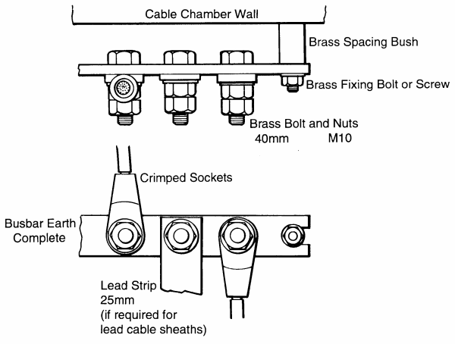

### Fixing the earthing conductor and other conductors

The arrangement is shown in Figure 6.2. The earthing conductor from the earth electrode system should be brought into the cable chamber via a suitable length of duct which is sealed in accordance with EPT/UGP/B033. The conductor should be fixed to the wall by means of wiring cleats and brass screws, the wall being plugged where necessary. The internal conductors from the main earth bar should be fixed to walls in a similar manner.

Figure 6.2 - Details of Main Earth Bar and Connections.

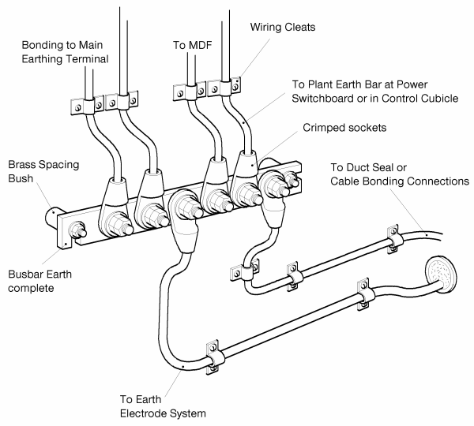

### Connection of conductors to the main earth bar

The conductors should be terminated in crimped sockets which should be bolted tightly to the bar. To obtain good electrical contact the sockets (and lead strip when used) should be lightly soldered to the bar. Each connection should be clearly labelled.

If suitable connectors and a crimping tool are not held locally, they can be obtained, via local purchase, from:

ELPRESS-UK

Unit 4 Carraway Road

Gillmoss Ind Est

Liverpool

L11 0EE

Tel: 0151-547 2666

Fax: 0151-547 1444

<http://www.elpress-uk.com>

Or from BT tools supplier: - TW Engineering, via iBuy

Contact: Mick Passey [m.passey@tweng.co.uk](mailto:m.passey@tweng.co.uk)

Tel: 0115 932 3223.

### Selection of the Earthing Conductor, etcetera

The earth electrode system should be connected to the main earth bar by 35sq.mm green/yellow sheathed cable.

Other conductors connected to the main earth bar should be selected in accordance with BS 7671.

## Records

The position of the earth electrode system and its initial resistance should be recorded to assist future measurements.

## Routine Measurement of Earth Electrode Resistance

### Routine Testing

The measurement of the earth electrode resistance will be carried out as part of the routine electrical test and inspection program. Under this program exchanges are routinely tested to BS 7671 (IET wiring regulations). In addition to measuring the resistance of the BT earth electrode the continuity of the connection between the Earth Busbar and the MDF will be verified.

### Method of Measurement

The method of measurement described in Section 10 should be used; alternatively the Zs method using an IET Wiring Regs tester may be used.

If an Ohmmeter 16A or similar tester is used, it is necessary to disconnect the earth electrode from the main earth bar. In this case it must be ensured that the telecommunications equipment in the building still has a functional earth. For example, the electricity supply earth should be bonded to the main earth bar and this will provide a connection to earth in the absence of the earth electrode. Or there may be lead cable sheaths connected to the main earth bar.

Testers of the UNILAP GEO X type can perform the measurement without the need to disconnect the earth electrode (similar units made by Megger or Fluke are available)

For further information on this tester contact the Supplier listed in section 11.3.

### Treatment of Results

The results will normally be held centrally by the Network Electrical Services group and where the standard of the earth electrode has deteriorated below the acceptable standard (8 Ohms) local management will be notified so that remedial action can be carried out. In the event of a fault being detected, with the earth outside of the routine testing, then contact Paul Eve, Power Policy Manager, in BT TSO (was BT Operate), so that remedial action can be taken.

### The Electricity Supply Earth

The electricity supply earth, if provided, will be tested when earth loop fault impedance measurements are made as part of the periodic inspection and testing of the electrical installation of the building. These measurements are required by BS 7671 (see ISIS document BES/ESV/A010).

### Lightning Protection Earthing System

Where lightning protection of a building is provided, BS 6651 recommends that the earthing system should be tested at least annually. Monteray / Telereal will normally arrange for testing to be carried out by contract.

# Planning an Earth Electrode System

## General

Operational buildings require an Earth Electrode Resistance that is better than 8 Ohms, to allow for Signalling, EMC and Protective Requirements.

1. If an earth electrode system is being installed as part of a mains power protection system, then the Wiring Regulations, BS7671, stipulate that all connections associated with that system need to be able to be inspected at any time. This may involve the fitting of earth inspection pits at each electrode. Consideration to the layout of the system should be taken and any impact it may have on 3rd parties (e.g. highways, neighbours, etc.)

External network Earth electrode Resistance requirements for lightning protection are contained in ISIS EPT/ANS/A020.

(This document contains full details of how to install and measure earth electrodes. In reality, a more pragmatic approach negates the need for such detailed planning in most circumstances).

A practical earth electrode system usually takes the form of a number of metal rods, driven vertically into the ground or of flat metal strips buried horizontally in a trench, or a combination of these constructions (see Figure 7.1). The resistance to earth of the electrode system must be sufficiently low for the application it is being used for.

The most cost effective method is to use vertically driven steel rods; see Section 7.4. Steel rods, however, corrode away and need to be renewed in 15 to 30 years. They should be used in situations where it is judged that their renewal at a distant date will be unlikely to present difficulty.

In very difficult locations where rocky or stony ground makes driving impossible, trenching may be used; see Section 7.5. Alternatively, a more suitable site some distance away may be selected for the earth electrode system but it should not be more than 300m from the site, a connection being made between them by overhead or underground wire or cable.

Where site conditions dictate it, a horizontally laid earth electrode system may be a preferable solution than a vertically driven rod system. See Risk Assessment in Appendix A

For Lightning Protection on BT’s External Network, a number of cost effective alternatives exist. Connecting to a pole stay, Copper tape under a wooden pole, and direct connection to a steel hollow pole are described in ISIS document EPT/ANS/A020.

A conductive concrete, encasing a copper ring electrode, as used in FTTC, is able to provide a long lasting low resistance earth electrode. The final value still depends on the earth resistivity, moisture conditions and surface area of the concrete. The installation of conductive concrete will vary depending on the application. See ISIS EPT/ANS/A055 for FTTC applications. Please contact the document author for any other earthing application.

Figure 7.1 - Examples of Earth Electrode Systems.

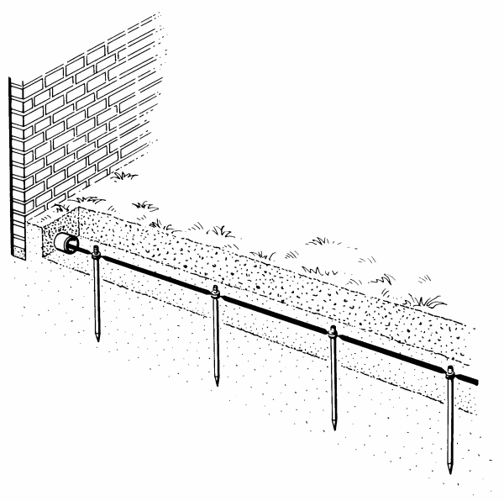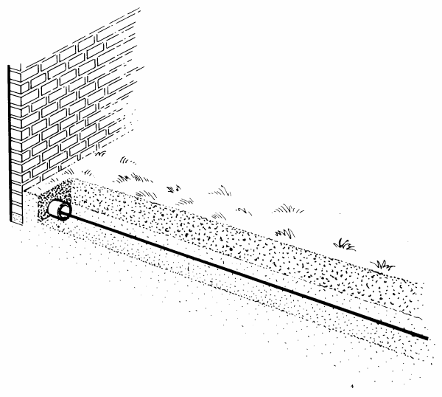

## Site of the Earth Electrode System

The site of the earth electrode system should be chosen so as to obtain a minimum clearance of ideally 0.6m or more from telecommunication cables, and also from electricity cables, gas and water pipes as other metallic services may contribute to the measured earth value of the rod, but cannot be guaranteed long term if the other services are disconnected or removed. Care must be taken to avoid damage to gas pipes, water pipes, drainpipes electric cables and sewers. The site should afford a convenient lead-in to where the earth is required. Insulated cables from the earth electrode can be as close as 50mm to other services, but doing so could render them liable to damage from other utilies digging the area.

## Soil Resistivity Measurements

To meet a given resistance to earth there must be a greater surface area of buried metal in an earth electrode system in a high soil resistivity area than in a lower soil resistivity area and it is therefore necessary at an early stage to make soil resistivity measurements (see Section 8) to determine the number of earth rods and/or the length of flat metal strip required; unless local knowledge makes this unnecessary.

The soil resistivity measurements will also indicate which type of earth electrode system will be more effective; for example, a single deep rod (2 or more rods screwed together), a number of single vertical rods in parallel, or tape laid horizontally.

For Lightning Protection Earths used in BT’s External Network and to avoid the time & cost of measuring Earth Resistivity, two standards have been agreed. Exchanges areas have been categorised as either Normal Resistivity or High Resistivity. (See excel spreadsheet below) The requirements for each type of resistivity are laid down in ISIS EPT/PPS/B055 - LP Handbook)

Soil Volume Resistivity of England, Wales and Scotland

 (Excel file)

## Vertically Driven Earth Rods

In situations where the resistance of the earth electrode system is not critical, (e.g. – signalling or test earth only – not for Lightning Protection), a Spike Earth 4 should be used. Section 9.3 describes how to install a Spike Earth 4.

Where it is necessary to achieve a specific value of resistance, or for Lightning Protection purposes, either Spikes Earth 3 or one of the methods described in Sections 7.5 to 7.10 or ISIS document EPT/ANS/A020 should be used.

1. When fitting an earth rod, the ground must be checked for other services. It is imperative that the ground is checked a number of times during the excavation. It may be necessary to fully dig the first 1.5m for a rod. Under no circumstances must a connection be made to any other services in the ground. A rod should be at least 15cm away from any other service, especially metallic ones.

When excavating the ground and another service is detected, then the rod position must be moved to the side and the excavation opened further to check for other services as in Figure 7.2

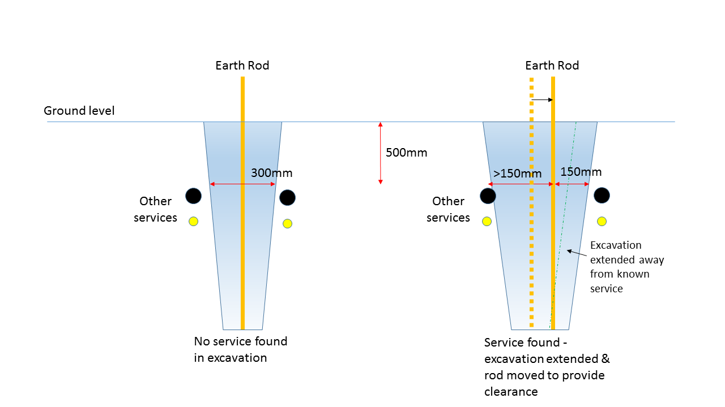

Figure 7.2: Separation from Other Services

The rod on the right has had to be moved to the right to maintain 150mm clearance to another service.

### Spike Earth 3

The standard BT earth rod is the Spike Earth 3 (see Figure 7.3). The components of Spike Earth 3 are available from BT Stores.

The electrode system consists of Rods Earth 3 which are ungalvanized mild-steel rods 1.5m (5ft) by 16mm (5/8in) threaded at both ends, which can be screwed together to form a long continuous rod (see 7.4.2). The continuous rod, together with a hardened tip and two hexagonal nuts for securing the earthing lead, is known as a Spike Earth 3. A driving head is available for driving the spike into the ground.

Depending on the depth to which the spike can be driven, the space available and the mean soil resistivity, you may have to drive more than one spike. In such cases connect an earthing cable, laid in trench or duct, between the tops of the spikes, [duct may be required if the cable is close, <300mm, to the surface to avoid dig damage]

The installation of Spike Earth 3 is described in Section 9.1.

Figure 7.3 - Spike Earth 3.

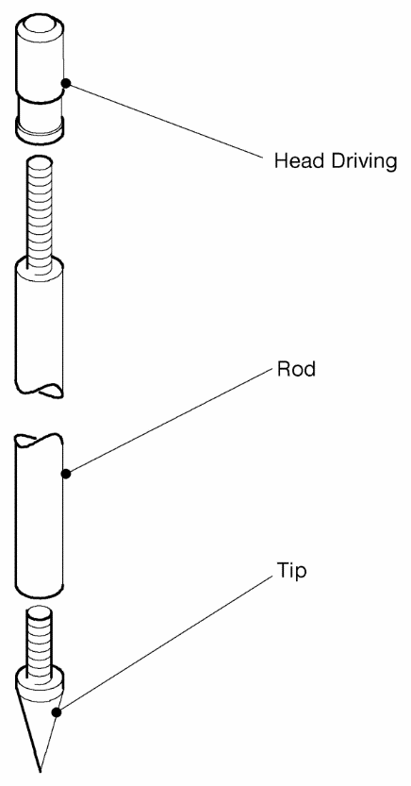

The driving head shall always be used to avoid damaging the threads of the rod when driving or at temporary reinstatement time. It should be tightened to the rod before driving, as if loose it may contribute to thread damage when driving in. The spiked tip will help in penetrating the ground, especially if stone or clay.

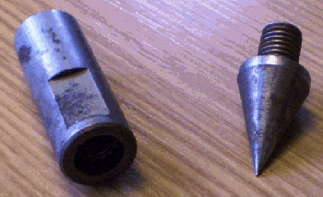

### The Length of Spike/Number of Spikes Required/Spike Spacing

For Lightning Protection in BT’s External Network, standards have been agreed, and these are documented in ISIS document EPT/ANS/A020 and a suitable task statement prepared to help with risk assessment in the appendix to this document.

For other uses, a more detailed investigation may be required:

The nomogram in Figure 7.4 gives a guide to the length of Spike Earth 3, and hence the number of 1.5m rods, required to construct an earth electrode system having a given resistance to earth. The nomogram gives approximate values of resistance for a single spike of lengths between 1.5 and 30 metres in soil of uniform resistivity ranging between 4 and 5000 Ohm.metres.

Unless soil resistivity decreases significantly with depth or there is only a limited space in which to install the earth electrode, a number of spikes in parallel are preferable to a single long spike. The number and spacing of spikes to be joined in parallel can be estimated by reference to Figure 7.5. The spacing between spikes should be not less than their length to ensure that each is outside the resistance area of any other. (The resistance area is the surface area around an earth electrode on which a significant voltage gradient may exist.). In simple terms, the spacing between two spikes shall be 2 x depth of the spikes, so for two 1.5m spikes the spacing shall be 3m.

Figure 7.4 - Resistance to Earth of Vertically Driven Spike Earth 3.

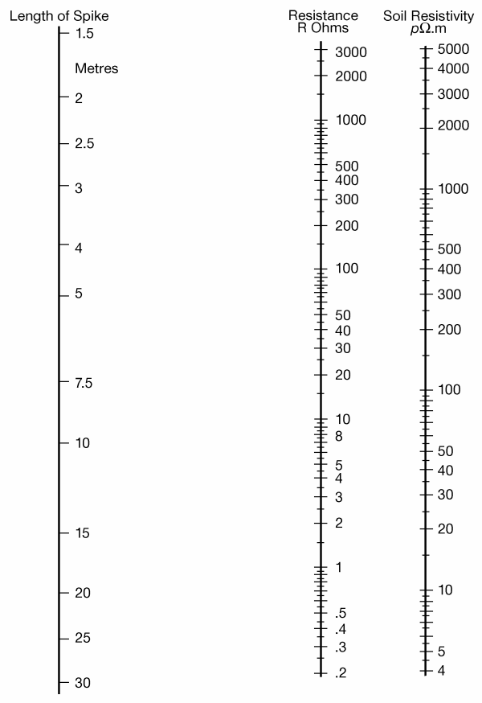

The family of curves in Figure 7.5 shows the resistance to earth, expressed as a percentage of the resistance to earth of one spike, of multiple spike electrode systems comprising 2, 3, 4, 5, 6, 8, 10 and 12 identical spikes driven vertically into the ground in a straight line at various spacings equal to simple ratios of the spike length.

BS 7430 gives guidance on how to calculate the resistance of other formations of earth spikes.

Figure 7.5 - Resistance of Multiple Spike Systems in Straight Line Formation

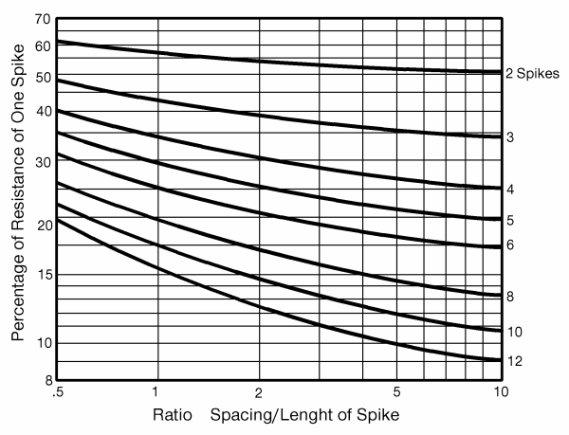

For example, if the soil resistivity of a site is 100 Ohm.metres and it is thought that a 3 metre spike can be installed without difficulty, then the nomogram in Figure 7.4 indicates that a single spike will have a resistance of 36 Ohms. To achieve a resistance of 8 Ohms with a number of spikes 3 metres long and spaced at 3 metre intervals, the required number can be read from Figure 7.5 as follows:

* Take the ratio of spacing/length = 1 along the horizontal axis.
* Look for a value of 8/36 = 22% on the vertical axis.
* This indicates that about 8 spikes are required

By doubling the spacing of the spikes, 6 spikes should be sufficient.

The use of more than one rod deep needs to be suitably risk assessed - see the Appendix for guidance, such that other services are not damaged and that safe working practices are used.

## Horizontally Laid Copper Strips

If the soil conditions are such that earth spikes cannot be driven in vertically to a useful depth then copper strip 25mm by 3mm (1in by 1/8in) should be laid at a depth of approximately 0.6m.

Strips should be placed away from other services, especially those that are metallic. A suggested minimum separation is at least 15cm.

If duct is being laid, copper strip can be placed at the bottom of the trench below the duct; this offers a convenient way of accommodating a considerable length of strip and involves little or no additional costs.

For Lightning Protection in BT’s External Network, standards have been agreed, and these are documented in EPT/PPS/B055 – Lightning Protection Handbook.

For other uses, a more detailed investigation may be required:

The nomogram in Figure 7.6 gives a guide to the resistance to earth of a copper strip, 25mm x 3mm, laid at a depth of 0.6m in soils of resistivity varying between 4 Ohm.metres and 5000 Ohm.metres.

Figure 7.6 - Resistance to Earth of Strip Buried in Trench

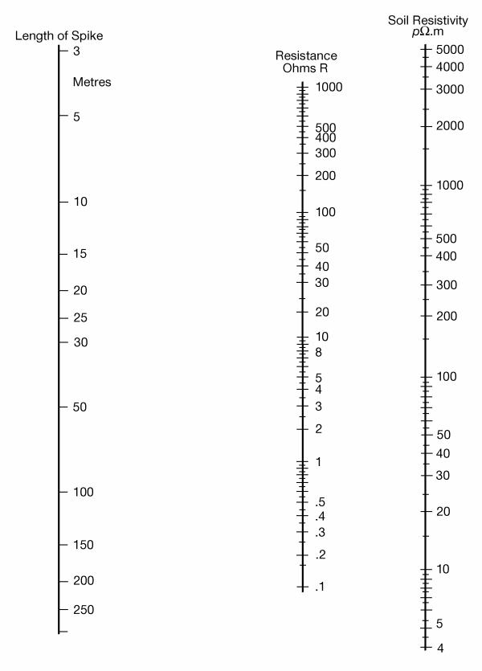

At some sites it may be necessary or preferable to lay the strip in other configurations than a straight line. Table 7.1 shows the percentage increase in resistance for various formations compared with the resistance of the same length in a straight line.

Table 7.1 - Resistance to Earth Increase

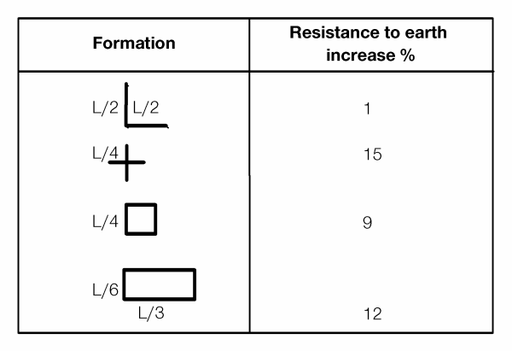

Two or more strips can be laid in parallel and bonded together. The combined resistance depends on the length of the strips and their separation.

For example, from the nomogram it can be found that a 30m strip buried in soil of resistivity 300 Ohm.metres will have a resistance to earth of about 17 Ohms. Two parallel 30m strips placed 2m apart will have a combined resistance of about 11.5 Ohms. At 10m separation this falls to about 10.4 Ohms.

For further information about strip electrodes, see BS 7430.

More details on Installation of Horizontal Copper Tape is available at section 9.2

## Earth Electrode of Copper Tape under a Wooden Pole

See ISIS EPT/ANS/A020

## Earth Connection to Dropwire Ring within a Steel Hollow Pole

See ISIS EPT/ANS/A020

1. This practice will work on ALL Stainless Steel hollow poles.

For Galvanised Steel poles, initial supply was Bitumen coated from the base up to 1.7m, and therefore no good earth connection can be obtained. All future supply will leave an uncoated section from the base to 1m and will obtain a suitable earth. To assist in identifying which galvanised poles may be used:

Locate the Code stamped on the Drop wire ring: (e.g. BT 9.0L 2 GS 05)

In this example – 2 is the batch number

Batch 1 Galvanised Steel poles will NOT provide a good earth

Early Batch 2 Galvanised Steel poles will NOT provide a good earth

All Later Batch 2 Galvanised Steel poles WILL provide a good earth, and will be marked by the supplier with a sticker inside the pole stating “Self Earthing”

All future batches will obtain a good earth.

## Earth Connection to Pole Stay

See ISIS EPT/ANS/A020

## Copper or Copper- Clad Electrodes

In urban areas earth electrodes are often built upon or concreted over, making renewal difficult or even impossible. In such cases copper-clad steel rods or copper strip or a combination of these should be used. Copper, although expensive, is a durable metal and copper-clad steel rod or copper strip is likely to give a service life in excess of 50 years.

Copper-clad rods of the same diameter and length as Spikes Earth 3 will provide an earth electrode system of similar resistance to one constructed from Spikes Earth 3. These will need to be locally purchased.

Table 7.2 lists suppliers of copper-clad steel rods, though there will be numerous other sources of such rods. The suppliers will provide details of their products and accessories. The items needed from the suppliers should be obtained via local purchase units.

Where two or more spikes are installed they should be joined together by bare 25mm by 3mm (1in by 1/8in) copper strip and connected to the main earth bar by a 10sq.mm or 35sq.mm green/yellow PVC insulated cable. The suppliers manufacture a range of clamps for making these connections.

Table 7.2 - Suppliers of Copper-clad Steel Rods.

|  |  |
| --- | --- |
| BICC COMPONENTS LTD  4 Hall Lane  PRESCOT  Merseyside  L34 5UR  Telephone: 0151 430 7555 | BB PRICE LTD  PO Box 17  HALESOWEN  West Midlands  B63 3HX  Telephone: 01384 413341  [www.bbprice.co.uk](http://www.bbprice.co.uk) |
| W.J. Furse and Co Ltd  Wilford Road  NOTTINGHAM  NG2 1EB  Tel: 0115 964 3700  [www.furse.com](http://www.furse.com) | TW Engineering, via iBuy  Contact: Mick Passey [m.passey@tweng.co.uk](mailto:m.passey@tweng.co.uk)  Tel: 0115 932 3223 |

## Special Construction Methods

Soil treatment or replacement to improve earth electrode contact resistance may be used in special or difficult locations when all standard methods have been exhausted. Migration and leaching of applied chemicals over a period of time reduces the efficiency of soil treatment progressively, requiring constant monitoring and replacement of the additives. Ecological considerations and any local environmental bylaws should be considered before such treatment is commenced, plus any deleterious effect upon electrode material has to be taken into account.

### Salting of Electrodes

This practice aims at affecting a lower electrode resistance to earth by artificially decreasing the resistivity of the surrounding soil by treating it with salt or salt solutions. The salts generally used are sodium chloride, sodium sulphate, potassium chloride, copper sulphate and copper ferrocyanide; the last being formed by making copper sulphate solution to soak into the soil and an equivalent volume of potassium ferrocyanide solution to follow it.

However, the salting of earth electrodes is not preferred because it pollutes the environment and may enhance the risk of corrosion to nearby buried metal structures. Moreover it is only partially effective, as the salts leach into the soil for only a few metres and their dilution is proportional to the square of the distance. Thus in the case of strip buried in a trench considerable reduction in resistance to earth is likely to follow salting over the entire lengths of the electrode but salting around a vertical electrode will affect only the top half metre of the spike and little reduction in its overall resistance to earth will result. Also, salts will leach away in time and this introduces a maintenance responsibility for re-salting at intervals.

### Soil Replacement and Conductive Compounds

It may be desirable to replace the soil immediately around an electrode with a lower resistivity material such as bentonite, marconite or concrete loaded with marconite. Benefits of using this type of material are claimed up to a 30% improvement. Other conductive compounds are available, such as conductive concrete. (See 7.10.2.1 and EPT/ANS/A055 for details)

Such treatment may be used to advantage in rocky terrain. Where holes are bored for insertion of vertical earth electrodes, or where strip earth electrodes are laid radially under shallow areas having a low resistivity which overlay rock strata, suitable treatment will reduce the contact resistance with respect to the general mass of ground.

The use of coke breeze as an infill is not recommended as it may result in rapid corrosion not only of the electrode itself but also of cable sheaths.

The resistivity of bentonite varies from about 3 Ohm.metres upwards, depending on its moisture content. It is hygroscopic and will absorb available moisture from the surrounding soil. Should it become dry, due to a complete absence of moisture in the surrounding soil, its resistivity rises appreciably and it will shrink away from the electrode.

The resistivity of concrete is in the range 30 Ohm.metres to 90 Ohm.metres. When Marconite is mixed as part of the aggregate, then the resistivity can fall to as low as10 Ohm.metres. If put around an earth rod it increases the effective diameter of the rod and hence its surface area in contact with the surrounds and hence lowers the overall earth impedance of the electrode.

Marconite can give varying results, though it needs to be compacted well for best results. Mixing with bentonite may also help. Marconite may be used as a filler within concrete to help reduce the resistivity of the concrete when steel reinforcing bars are used. We have no data on how it affects the strength of the concrete.

For further information about the use of infill materials see BS7430.

The use of Marconite or Bentonite as a backfill around earth electrodes is an option, but the benefit is not easily determined (it may give from a few % to 30% decrease in earth electrode impedance). It is a decision the project manager should take when factoring in the cost of such material. If used as part of a soil backfill mix, then no water should be added to the backfill. Compaction of the soil should be as firm as possible to avoid any voids. If marconite is used as part of a concrete mix, then the manufacturers suggest adding a small amount of water to produce a ‘dry mix’ for compacting around an electrode.

#### Conductive Concrete

Conductive concrete is a cement based product, which can encase a copper electrode and provide a means of earthing. It may also be used in other instances to surround a traditional earth electrode. Note, conductive concrete does not necessarily give an instant earth electrode of acceptable value. It takes time for the compound to cure and become effective (possibly up to 28 days after installation). It is recommended that a minimum of 2 weeks from date of installation is given before measurements or electrical work is carried out i.e. the compound needs to fully cure to become an effective earth electrode.

### Deep Drilling

In some situations it may be preferable to use a single long vertical earth rod. This is installed by drilling a deep hole, lowering the rod into it and then backfilling the hole with a suitable mixture.

In soft rock such as sandstone you can sometimes drill a vertical hole about 50mm diameter and up to 27m deep using a pneumatic drilling rig. Screw the earth rods together and lower them into the hole, then back fill using a slurry of gypsum and bentonite clay mixture (or Marconite) pumped to the bottom of the hole through a 30m length of Duct 102. Withdraw the Duct 102 as backfilling progresses.

For further information about deep drilling contact the lightning protection and earthing department of:

Protectis

12a Hazel Street

Bulwell

Nottingham

Telephone: (0115) 975 8820

This company provides consultancy on earthing and can arrange for estimates for work to be carried out.

# Measuring Soil Resistivity

## The Measuring Procedure (4-pole method)

Use an Ohmmeter 16A or a suitable equivalent to make this measurement. See Section 11.3 for measuring equipment.

Connect the Ohmmeter as shown in Figure 8.1, the four temporary spikes being arranged in a straight line so that the distances between adjacent spikes are equal. Connect the two outer spikes to the current circuit and the two inner ones to the voltage circuit. Drive all the spikes to an equal depth not greater than 1/20th of the distance ‘a’ between spikes.

Arrange the spikes so that the common mid-point between the two inner spikes and the two outer ones lies approximately above the ‘centre’ of the mass of earth to be measured.

If the ‘guard’ facility is required when an Ohmmeter 16A is being used (see Section 11.2) take a lead from the instrument guard terminal and connect it to a fifth spike positioned midway between the spike electrodes to which P2 and C2 are joined, see Figure 8.1.

Figure 8.1 - Measurement of Soil Resistivity.

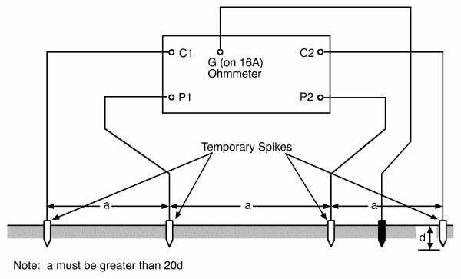

Take a set of resistance readings with the spikes spaced apart at distances of 2.5, 5, 10, 15, and 20 metres.

Take a further set of readings at the same spacings but with the spikes arranged along a second straight line at right angles to the first.

## Interpretation of Results

For each set of readings calculate the resistivities using the formula below and tabulate them against spike spacings. Alternatively, determine approximate values of resistivity from the nomogram in Figure 8.2.

Assuming that the soil is uniform, the mean resistivity 'p' to a depth equal to the distance ‘a’ between adjacent electrodes will be:

P - 2πaR

Where

a is the spacing between electrodes, in m;

R is the resistance measured between the middle electrodes, in Ohms.

Substantial agreement between the two sets of readings is an indication that the soil resistivity conditions at the site are uniform.

Figure 8.2 - Nomogram for Determining Soil Resistivity from Spike Spacings and Meter Readings.

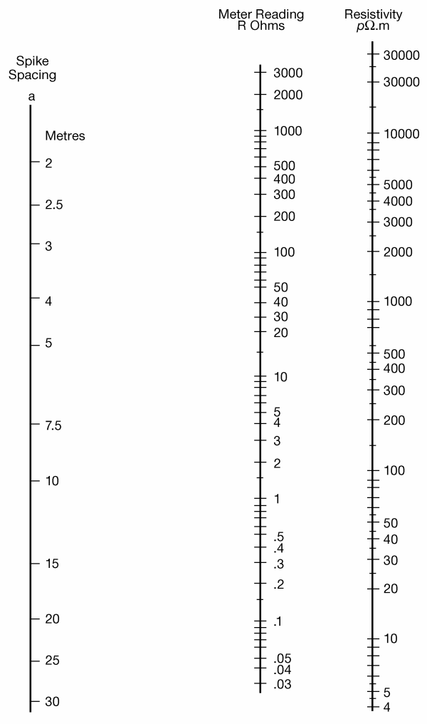

Sometimes, however, there is a considerable difference between readings at the same spike spacing, due to soil resistivity differences in the horizontal plane. Table 8.1 shows the results of tests taken at Benbecula illustrating such differences which are due to the presence of rock in the ground make-up.

Since each test indicates the mean soil resistivity to a depth equal to the spike spacing, each set of measurements provides a useful guide to any variation of soil resistivity with depth at the site. Three typical sets of measurements made at particular sites are given in Table 8.2. At Scarborough the soil resistivity is shown to be sensibly uniform to a depth of 20m; at Smallford it decreases with depth while at Benbecula it increases. Clearly in the construction of an earth electrode system at Smallford there would be advantage in driving the earth rods to a depth of at least 20m, whilst at Benbecula, shorter rods in parallel would be preferable.

Table 8.1 - Soil Resistivity Tests at Benbecula along Axes at Right Angles.

|  |  |  |  |
| --- | --- | --- | --- |
|  | Spike Spacing m | R Ω | pΩm |
| N-S Line | 2.5 | 70.4 | 1110 |
|  | 5 | 42.2 | 1330 |
|  | 10 | 31.9 | 2000 |
|  | 15 | 23.8 | 2240 |
|  | 20 | 18.7 | 2350 |
|  |  |  |  |
| E-W Line | 2.5 | 40.3 | 633 |
|  | 5 | 30.7 | 964 |
|  | 10 | 24.3 | 1530 |
|  | 15 | 21.0 | 1980 |
|  | 20 | 16.9 | 2120 |

Table 8.2 - Tests Showing Variations of Mean Soil Resistivity with Depth

|  |  |  |  |
| --- | --- | --- | --- |
|  | Spike Spacing m | R Ω | pΩm |
| Smallford (gravel with peat below) | 2.5 | 8.88 | 139 |
|  | 5 | 3.65 | 115 |
|  | 10 | 1.30 | 82 |
|  | 15 | 0.78 | 74 |
|  | 20 | 0.55 | 69 |
|  |  |  |  |
| Scarborough (uniform clay) | 2.5 | 1.70 | 27 |
|  | 5 | 0.78 | 25 |
|  | 10 | 0.40 | 25 |
|  | 15 | 0.25 | 24 |
|  | 20 | 0.20 | 25 |
|  |  |  |  |
| Benbecula (peat with rock below) | 2.5 | 40.3 | 633 |
|  | 5 | 30.7 | 964 |
|  | 10 | 24.3 | 1530 |
|  | 15 | 21.0 | 1980 |
|  | 20 | 16.9 | 2120 |

## Alternative Method of Determining Earth Resistivity (3-pole measurement)

If a 4 pole measurement system is not available, then it is possible to get a reasonable estimation of the soil resistivity by using the 3-pole measuring kit, as used when measuring an earth electrode. It does entail the fitting of a rod to its correct position in the ground, so should only be used when absolutely necessary and is not quite as accurate as the 4-pole method.

Install the rod at the correct depth and back fill such that the minimum of rod is exposed. Remember to ignore the length of rod 500mm from the surface of the land, so ideally install the rod below 500mm. Measure the earth electrode resistance as per the 3-pole method as detailed in section 10.1. If possible do this in a number of directions and distances from the electrode under test. The average reading should be used (note, it should not vary by more than a couple of Ohms if the solid composition in homogenous). Using the nomo-gram in Figure 7.4, take a line from the effective rod length used and the measured value of resistance to the earth resistivity line and read off the value. From this you can then determine how deep/long the earth electrode needs to be to hit your target value using the resistivity value just calculated.

It is wise to remeasure and recalculate the resistivity value when a second rod is attached as variations in soil composition will be averaged out.

# Installation of the Earth Electrode System

See Section 2, General Safety Requirements and the Safety Risk Assessment guidance in the Appendix.

1. Extra care should be observed if working on sloping ground or on Banked ground.

## Spike Earth 3

Using either a Lump Hammer or suitable mechanical aid fitted with a suitable earth electrode adapter for driving Spikes Earth 3.

*Note:* This practice is only safe in known virgin soil. It is best to fully dig the hole for the rod and make sure no other services are in proximity.

At the site, use standard safe digging practice to dig a hole 0.9m to 1m deep. Repeat the safe digging practice to ensure site is clear of other services. Screw a tip and driving head tightly to a rod and drive it vertically into the bottom of the hole.

(For Lightning protection in BT’s External network, it is not necessary to drive the rod to the base of the hole, as only 1 rod depth is required and there will be no need to join rods vertically – See EPT/ANS/A020 for standards.)

Where extended earth rod lengths are required (BT Building Earths, etc.); when the first rod has been driven in remove the driving head, screw a second rod to the first if necessary, using two wrenches to ensure the joint is tight, replace the driving head and continue driving. Further rods should be added and driven in until a sufficiently low resistance value has been achieved.

In general it should not be necessary to spend more than an hour in driving one spike and if driving becomes unduly difficult before the last rod has been driven fully in, widen the hole and bend the top of the rod over horizontally. If you know that a rock stratum exists several feet below the surface and deep driving would be impossible, drive the rods in at a convenient angle.

If driving becomes unduly difficult before you achieve sufficiently low resistance you will have to drive additional spikes. In practice, the depth to which the spikes can be driven, the number of spikes required and the spacing between them can only be decided by previous experience or after the first spike has been driven.

In general, any additional spikes required can be driven to approximately the same depth as the first spike.

In all cases - When the spikes have been driven in, dig trenches at least 0.3m deep between the spikes and between the first spike and the point where the earth is required. A short length of Duct 56 should be used to guide the cable to the surface. There is no need to have duct between each rod unless protection from digging is necessary (<300mm DOC).

Draw 35sq.mm or 10sq.mm cable with a yellow/green sheath into the duct and connect the spikes together. Make all terminations with crimped connectors and use washers either side of the crimp (see Figure 9.1). Connectors and crimping tools are available from ELPRESS-UK or TW Engineering see Section 6.3.3.

If the cables connecting the spikes together are in a position where they are unlikely to be damaged by digging, etc., lay the cables direct in the ground. Should some degree of protection be needed, lay boards over the cables. If two or more spikes are installed, join them together by the shortest and most practicable route. The first and last spikes need not be connected together to form a closed loop unless the trench and connecting cable are short, or there is a possibility of the connections being subsequently disturbed.

The top connections of the spikes are most liable to corrosion and should be well wrapped with Tape Sealing 3, 50mm. Fill in all excavations and make good the surface.

Figure 9.1 - Terminating Earth Wire to Spike Earth 3

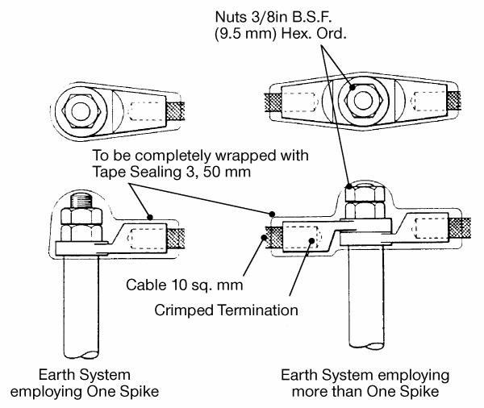

Note: drawing has washers omitted. One nut minimum required

Figure 9.2 - Terminating Earth Wire to Copper Strip.

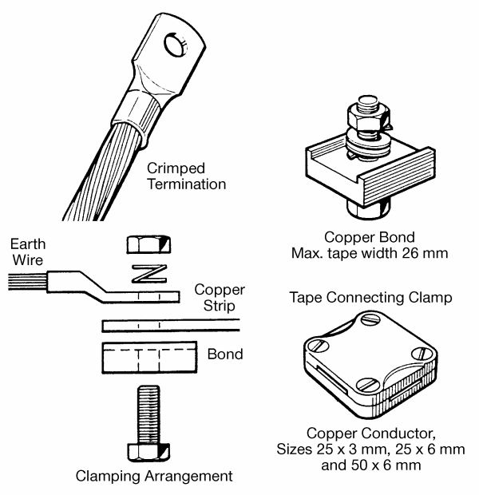

## Copper Strip

Copper strip, 25mm by 3mm, should be laid in a trench at a depth of 0.6m or deeper. (Where new duct is being provided, this tape will be installed under the new duct, but will be at an Absolute Minimum Depth of Cover of 400 mm with increased overall length.)

Connect a 35sq.mm or 10sq.mm cable with yellow/green sheath to the copper strip as follows (see Figure 9.2).

Crimp a tin plated electrolytic copper tube terminal on to the end of the earth cable.

Drill a hole of a suitable size through the copper strip.

Clamp together the copper strip and the earth wire terminal using a bond shown in Figure 9.2.

The crimped terminations are available from ELPRESS-UK or TW engineering, addresses in Section 6.3.3. The other items are available from WJ Furse & Co Ltd, address in Section 7.9.

## Spike Earth 4 (Not for Lightning Protection use)

Dig a hole approximately 300mm square and 300mm deep. Drive the spike into the ground in the middle of the hole until the top of the spike is 150mm below ground level.

Connect the earth wire to the spike using Clip Earth 3 and cover the whole termination with Tape Sealing 3, 50mm. The type of earth wire to be used will depend on the application; for example for pole signalling earths Wire Copper Soft 1.4mm diameter should be used.

The practice may be different for external payphones.

## Conductive Concrete Earths

Please see ISIS EPT/ANS/A055 for conductive concrete use within FTTC. Please refer to the document author for other applications of conductive concrete.

# Measuring Earth Electrode Resistance

When the installation of the earth electrode is complete, its resistance can be measured as described below. When measuring the resistance care should be taken in the measurements and it should be proven to be a stable value at a minimum of three probe measurement positions (See Guidance Note 3 to BS 7671, section 2.6.14, Test method 1). When a measurement is required to prove compliance to BS 7671 (Wiring Regulations), then all test equipment shall be calibrated.

It may be possible to use Guidance Note 3, BS 7671, section 2.6.14, Test method 2 if mains power is available.

1. When needing to meet a maximum value, try and make the measurement under ‘normal’ weather and water table conditions. The ‘normal value’ target value should always be aimed to be at least 10% below the maximum allowed value so as to account for very dry conditions. If the ground conditions are very wet then the normal value should be reduced to account for the greater conductivity of the soil, possibly by 10%. E.g. maximum value (target) = 20 Ohms, ‘Normal’ value = 17 Ohms, Wet value = 15 Ohms.

If measuring using the three probe method then allowance should be made for electrical certification purposes if a further measurement is to be made via the power network, which could increase the value by as much as 1 Ohm.

## Measuring Procedure

Use an Ohmmeter 16A or a suitable equivalent to make this measurement. See Section 11.3 for further details of measuring equipment.

Connect the earth electrode to be measured to the strapped P1 and C1 terminals of the Ohmmeter. Drive the two test spikes into the ground to form the temporary electrodes, in the positions shown in Figure 10.1. Use lengths of cable to connect the spike electrodes to the C2 and P2 terminals as appropriate.

Figure 10.1 - Standard Method of Measuring Earth Resistance.

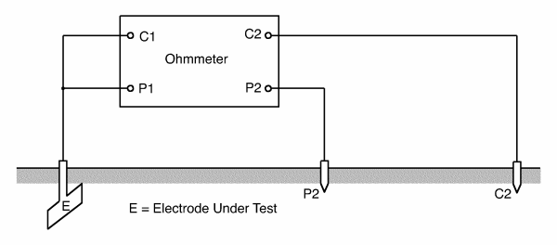

When the guard circuit of the Ohmmeter 16A is used, place the guard spike midway between the spikes connected to the C2 and P2 terminals and connect to the guard terminal of the Ohmmeter (see Section 11.2).

Take three readings; the first with the voltage spike electrode approximately midway between the current spike electrode and the electrode under test; the second with it 3m nearer the current electrode and the third 3m nearer the electrode under test.

If the difference between the minimum and maximum readings is not greater than 5% of the average of the three readings, the average reading may be taken as the earth electrode resistance. If the readings are outside this limit, move the spike electrodes to a greater distance from the electrode under test and repeat the test until agreement within 5% is reached.

For an earth electrode consisting of a single rod, place the current spike electrode about 25m away. If there are several rods in parallel, increase the distance to 50m and for a more extensive structure a distance of 150m to 200m may be required. The voltage and current spikes should be roughly in line with the earth electrode under test and they must not be placed within 3m of any earthed structure (for example water pipes or BT cables).

## Measuring Methods to be Used where the Standard Method Presents Difficulties

### Use of Remote Earth Electrodes

If you experience difficulty in testing by the standard method, connect P2 and C2 to remote isolated earth systems or spike electrodes via cable pairs (see Figure 10.2). The connections must be over unloaded wires or bunched pairs and in separate cables if the distance exceeds about 3km. This method is useful if the site is too congested for tests to be made as described in Section 10.1.

Figure 10.2 - Use of Remote Earth Electrodes

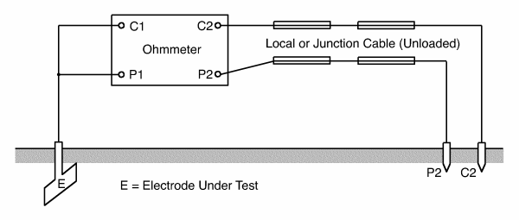

### Use of Two Electrodes Method

This method of testing should only be used if it is impossible to use the standard method, for example if no suitable positions for driving earth spikes are available but a low resistance earth electrode such as a water main is accessible (see Figure 10.3). A known metallic water main usually provides a very low resistance to earth and may be used provided neither water main nor any subsidiary pipe passes within 3m of the earth electrode to be measured.

Figure 10.3 - Two Electrodes Method

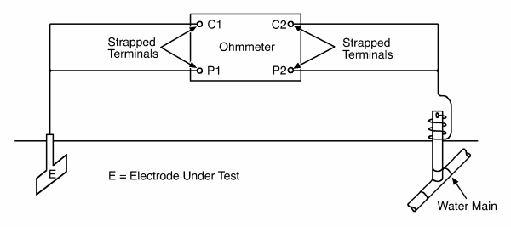

Connect the linked P2 and C2 terminals of the Ohmmeter to the low resistance earth electrode P1 and C1 to the earth electrode under test.

The measured resistance will be that of the two electrodes plus the connecting wires, in series. If the resistance of the second earth electrode is very low, it may be neglected.

# Test Equipment

## Typical Test Equipment

A typical set of equipment is listed below:

* Ohmmeter No16A or suitable Earth Electrode Meter (calibrated)
* Two 100m reels of flexible 1sq.mm wire PVC insulated
* Two 50m reels of flexible 1sq.mm wire PVC insulated
* Two 25m reels of flexible 1sq.mm wire PVC insulated
* Five Test Spikes
* Measuring tape of suitable length; or
* Measuring cord, 60m long, with markers attached at the spacings shown below:



* Wheel measuring; available from BT stores, Item Code 117652
* Spikes for pinning measuring cord
* Club Hammer, 2 1/2lb (or 1kg)
* Short Leads
* Connectors; for example, crocodile clips.

## Ohmmeter 16A

This instrument is of the null-balance type and will measure values from 0-9990 Ohms in 4 ranges (0-9.99; 0-99.9; 0-999; 0-9990), these ranges being obtained by adjustments of the turns ratio of the transformer. The current and voltage circuits are terminated on terminals marked C1, C2, P1 and P2. A guard facility is provided to minimise the effect of leakage within the instrument when measuring exceptionally high soil resistivities or spike electrode resistances, or when the ambient humidity is very high. If these conditions exist, take several readings with the GUARD terminal connected to a spike electrode positioned midway between C2 and P2. Compare these readings with readings taken without the guard connected. If the readings differ by more than 1%, use the guard for all tests. If the readings differ by less than 1%, omit the guard connection.

The Ohmmeter 16A is no longer available from BT stores. Other suitable testers are listed in Section 11.3.

## Earth Testers Other Than the Ohmmeter 16A

Other suitable testers are listed below. They should be obtained via local purchase units.

|  |  |  |
| --- | --- | --- |
| Supplier | Supplier’s Code | Remarks |
| AVO -Megger  Archcliffe Road  DOVER  Kent  CT17 9EN  Tel: 01304 502101  Fax: 01304 207342  www.megger.com/uk | DET 3/2 | This is a direct replacement for the Ohmmeter 16A. An accessory kit is available separately. |
| LEM UK Limited  West Lancs. Investment Centre  White Moss Business Park  Skelmersdale WN8 9TG  Tel + 44 1 695 712560  Fax +44 1 695 712561  www.lem.com | UNILAP GEO  UNILAP GEO X | Both instruments come with accessories.  The GEO X is capable of measuring earth electrode resistance without disconnection of the electrode from the earth terminal. To use this method additional items are required. |
| Martindale Electric  Metrohm House  Penfold Trading Estate  Watford  WD24 4YY  Tel: (01923) 441717  Fax: (01923) 446900 | METROHM E1610 | An accessory kit is available separately.  Note: This company supplies ONLY via retailers – Use this contact to obtain details of local retailers |
| Fluke and Kewtech also make similar test kit for earth resistance measurements. |  |  |

# Stores List

Listed below are those parts not listed in EPT/ANS/A020

|  |  |  |
| --- | --- | --- |
| Item | Item Code | Remarks |
| Busbar Earth Complete | 070248 | Now obsolete on eASC |
| Copper strip 25mm x 3mm | Locally Purchased | Specification for tapes, with earth tails for use in trenches or on the base of poles can be found in the attached document - |
| Copper tube termination }  Crimping tool } | Locally Purchased | Obtainable from  ELPRESS-UK |
| Cable ELP 6491X 35sq.mm GN/Y | 791552 | Now obsolete on eASC |
| Tape Sealing 3 (50mm) | 071305 | - |
| Spike Earth 4 | 014954 | - |
| Clip Earth 3 | 011550 | This is an A-D type suitable for up to 10mm2 cable only. |
| Washers | Locally Purchase | for Rod Earth 3 |
| Nut 3/8” BSF | 013350 | for Rod Earth 3 |
| Heads Driving | 012201 | for Rod Earth 3 |
| Spike Tip | 015951 | for Rod Earth 3 |
| Rod Earth 3 | 014450 | - |
| Earth Clip Type E | Locally Purchased | For use with 16mm2 cable |
| Earth Clamp | Locally Purchased | For use with 16mm2 cable |
| Safety Labels | Locally Purchased | For installation to conform with BS 7671 |

# Enquiries

Technical Enquiries may be directed to the document author.

See also Video – “Lightning – Protecting BT’s Network from It’s Power” –

<https://intra.bt.com/bt/openreach/our-organisation/service-design/chief-engineer/insight-videos/Pages/Engineering-Copper.aspx>

# Appendix A: Safety Risk Assessment

The attached document is the risk assessment provided by BT Safety Services. 

Also available is the 

END OF DOCUMENT